  www.vidaproducts.com | HAMMERHEAD HIGH PERFORMACE  YIG-BASED FREQUENCY SYNTHESIZERS
Revision # 1 09/08/04  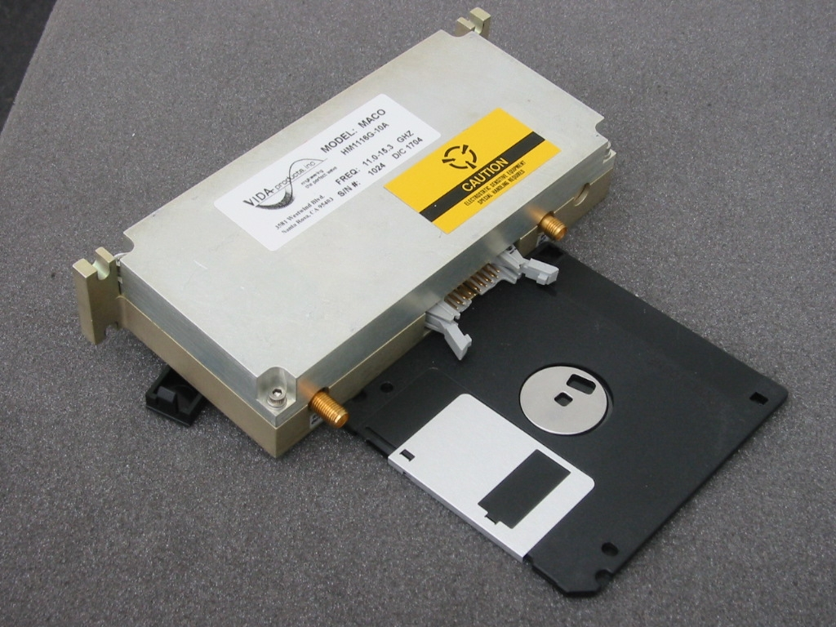 | The Hammerhead family of YIG-based frequency synthesizers is designed to meet the demanding requirements of high data-rate digital radios, satellite communications systems, fast switching radar and sensor systems that must be tunable over wide frequency ranges, and very secure military communications systems. VIDA’s patented technologies provide the broad tuning bandwidth, spectral purity, extended temperature performance, microphonic & phase hit resistance, and ultra low phase noise required by next generation commercial and military systems.
Key Features  - Frequency Coverage from  1 to 30 GHz  - Tuning Range up to a full octave for maximum system flexibility  - Step size options down to below 100kHz  - Switching speeds down to below one millisecond  - Outstanding spectral purity for high data rate modulation schemes  - Extremely low phase noise for optimum communication security  - Significantly reduced microphonics  - Dramatically enhanced phase hit performance  - Modular design for maximum configuration flexibility | Enhanced Technology for Better Price vs. Performance  The Hammerhead Synthesizer family delivers outstanding spectral purity with phase noise performance of -120 dBc/Hz at 100kHz offsets, allowing high data rate modulation schemes and very secure communication. These affordable synthesizers are based on patented YIG oscillator technology and key synthesizer product performance enhancements that allow low power operation with very low microphonics and virtually phase-hit-free performance.  High Volume Production  VIDA Products has consistent product quality and manufacturing controls in place. VIDA’s high volume manufacturing procedures and the exclusive use of surface mount technology lead to the lowest possible costs with the highest possible manufacturing efficiencies. The patented VIDA Oscillator design requires only minimal tuning. Every unit is fully tested to ensure that all performance elements meet customer requirements.  Flexible Configuration  The Hammerhead Synthesizer product family utilizes a modular design which allows VIDA to quickly develop custom solutions to meet specific customer requirements. |  |  |  |  | Available Options Include  - Frequency coverage from 1 to 30 GHz in frequency divided, non-doubled, and doubled configurations.  - Standard step size options as low as 100 kHz with smaller sizes available on special order.  - Switching speed options down to one millisecond.  - Internal or external reference source options are available. Internally referenced units can provide a 25 MHz output reference for use elsewhere in the system. External references of 10, 25, 28, and 50 MHz can also be accepted.  - Single or dual output alternatives are available.  - Nominal output power levels can be customer-specified.  - DC input power voltage of +12 or +15 V  - Lower total power requirements options are available.  Contact VIDA Products, Inc. Today!  VIDA’s product line includes an array of both commercial and military YIG-based components and sub-systems utilizing patented YIG oscillator and filter technology. Call or email today and let us recommend a solution to your application based on the Hammerhead modular design approach . . . either a standard off the shelf product or a customized design. Whatever the application, VIDA can provide the most cost effective solution that meets all your system performance requirements.
HAMMERHEAD YIG-BASED SYNTHESIZER CAPABILITIES
Output Specifications |  | Units | Divided Frequency |  |  |  | Prime Frequency | Doubled Frequency
 |  |  | ÷ 2 | ÷ 4 | ÷ 8
Output Frequency |  | GHz | 0.7 – 6.0 |  |  |  | 5.5 – 12.0 | 11.0 – 24.0
Maximum Frequency Span |  | MHz | 2:1 (Full Octave) |  |  |  | 2:1 (Full Octave) | 2:1 (Full Octave)
Step Size (Standard) |  | kHz | 50 | 50 | 50 |  | 100 | 200
Nominal Output Power (Single Output) |  | dBm | 13-20 |  |  |  | 13-20 | 13-17
Nominal Output Power (Dual Output) |  | dBm | 10-17 |  |  |  | 10-16 | 13
Output Power Tolerance |  | dB | +/- 2 |  |  |  | +/- 2 | +/- 2
Port to Port Isolation (Dual Output) |  | dB | >15 typ |  |  |  | >15 typ | > 15 typ
Harmonics |  | dBc | <-15 |  |  |  | <-13 | <-15
Sub-Harmonics (Doubled Models Only) |  | dBc | N/A |  |  |  | N/A | <-40
Spurious (>50 kHz Offset) |  | dBc | -60 |  |  |  | <-70 | -64
Integrated Phase Noise (Including Spurious)  100 kHz – 30 MHz Offset |  | dBc | -70 | -75 | -80 |  | <-69 | <-62
SSB Phase Noise, 1 kHz Offset |  | dBc/Hz |  | -84 |  |  | -74 typ | -66 typ
SSB Phase Noise, 10 kHz Offset |  | dBc/Hz |  | -104 |  |  | -94 typ | -88 typ
SSB Phase Noise, 100kHz Offset |  | dBc/Hz |  | -130 |  |  | -122 typ | -116 typ
SSB Phase Noise, 1 MHz Offset |  | dBc/Hz |  | -140 |  |  | -146 typ | -144 typ
SSB Phase Noise, 5 MHz Offset |  | dBc/Hz |  | -146 |  |  | -150 typ | -144 typ
SSB Phase Noise, 10 MHz Offset |  | dBc/Hz |  | -146 |  |  | -153 typ | -147 typ
Phase Hit Deviation After 50 kHz  First-Order High Pass Filter |  | degrees | <2 |  |  |  | <5 | <7
Reference Output Frequency |  | MHz | 25
Reference Output Level |  | dBm | +6 to +11
Reference Output Phase Noise 100 Hz Off |  | dBc/Hz | -120
Reference Output Phase Noise 1 kHz Off |  | dBc/Hz | -140
Reference Output Phase Noise 10 kHz Off |  | dBc/Hz | -145
Reference Output Phase Noise 100 kHz Off |  | dBc/Hz | -150
Alarm Output |  |  | Customer Specified
Input Specifications
Switching Speed, Nominal for 1,000 MHz |  | ms | 30 (1ms fast switching option available)
DC Power Input Voltage, Nominal |  | V | +12 or +15 (8 Volt Low Power Option Available)
Total Power (Std.) (Low Power Option Available) |  | W | <9
DC Input Current |  | mA | 0.75
Control Input (Option) |  |  | 3-Wire Serial TTL (clk, data, enab)
Control Input (Standard) |  |  | Complies With I²C Standard
Power/Control Connector |  |  | 16-Pin Latch/Ejector Header  (3M 3408-1302)
Reference Input Frequency (Options) |  | MHz | 10, 25 28, or 50
Reference Input Level |  | dBm | -3 to +11
Reference Input Phase Noise 100 Hz Off |  | dBc/Hz | <-120
Reference Input Phase Noise 1 kHz Off |  | dBc/Hz | <-140
Reference Input Phase Noise 10 kHz Off |  | dBc/Hz | <-145
Reference Input Phase Noise 100 kHz Off |  | dBc/Hz | <-150  <-120
Reference Input Spurious (Offset <100 kHz) |  | dBc
Physical
Length |  | inches | 5.75
Width (Not Including Connectors or Mntg. Hrdw.) |  | inches | 2.75
Thickness |  | inches | 1.185 (thinner options available)
Environmental
Ambient Operating Temp. (Heat Sinking/Air Flow Limits Case Temp. to 5 Deg. C Above Ambient) |  | Deg. C | -10 to +70
Operating Humidity |  |  | 5% – 90% Non-Condensing

Specifications Subject to Change Without Notice

